**Steps to create a standard class in java**

1. **first statement in a '.java file' is package declaration (one or none)all class should be created inside a package.**
2. **Second statement is import, (none or many)**

**Only public classes can be imported.**

1. **Public class**
2. **Private instance variable**
3. **Private static variable**
4. **Static initializer block**
5. **Initializer block**
6. **No-arg constructor**
7. **Overloaded constructor**
8. **Getters and setters also known as accessors and mutators**
9. **Override toString() method**
10. **If dealing with collection, then override equals() and hashCode() methods of object class.**
11. **If need sorting then implement Comparable interface and override compareTo() method.**

**Generate constructor using field**

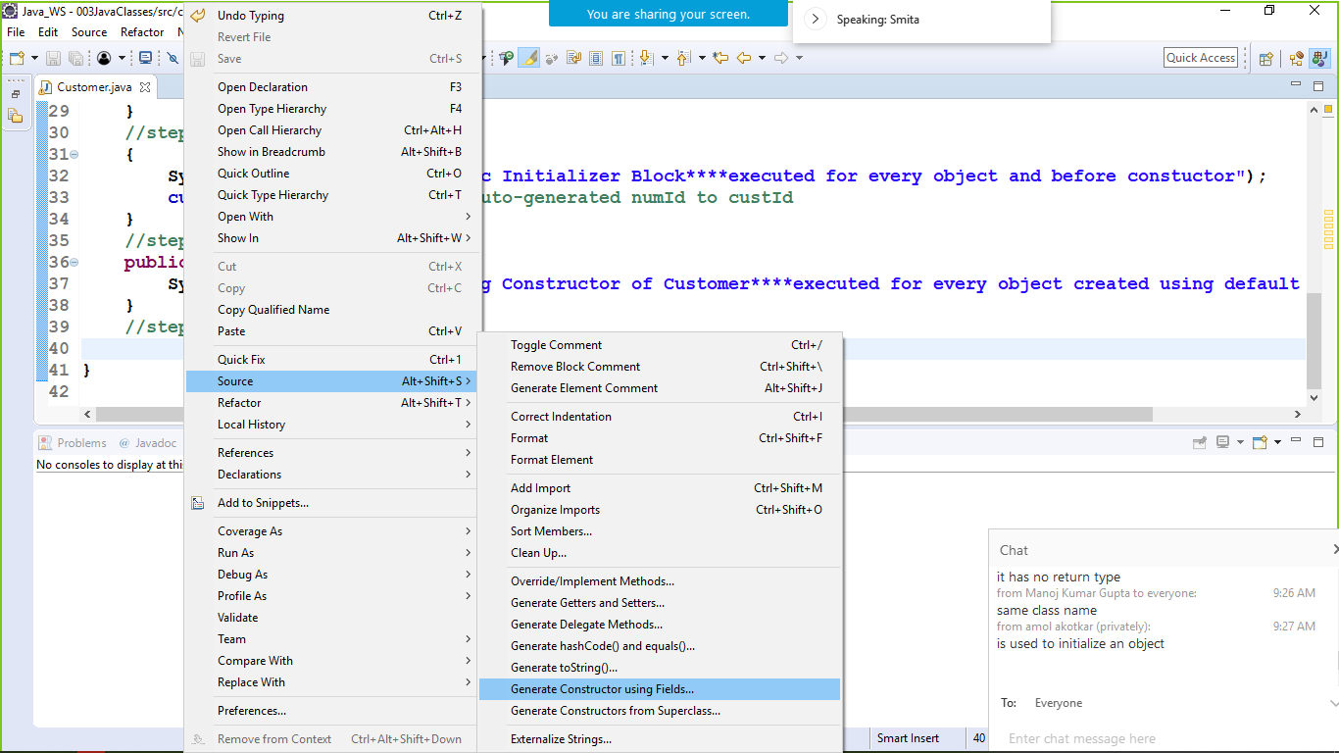

Not selecting id as it will auto-generated

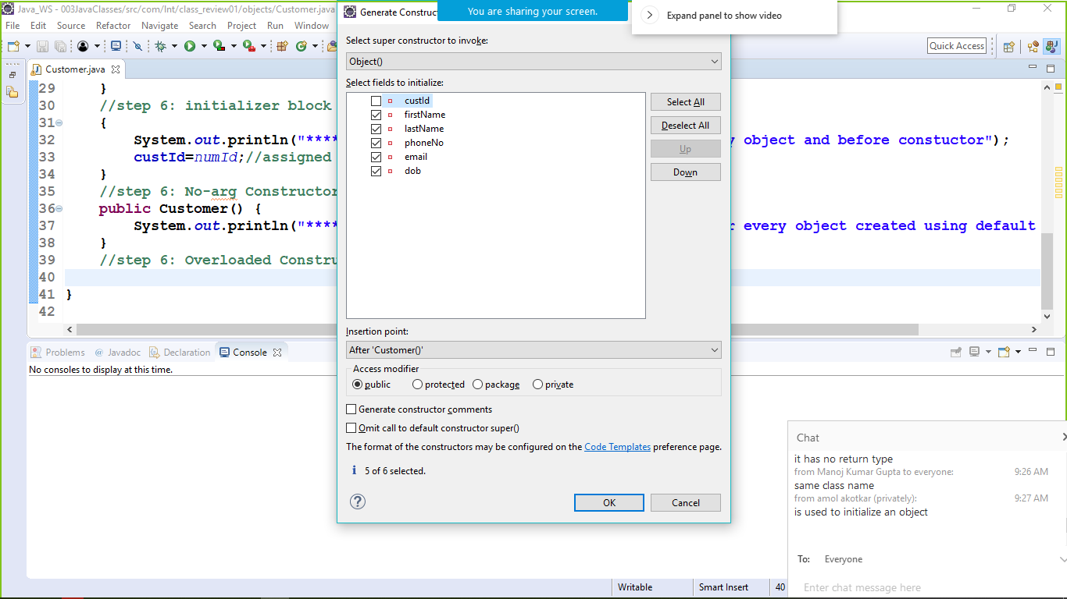

//step 6: Overloaded Constructor

**public** Customer(String firstName, String lastName, String phoneNo, String email, Date dob) {

**super**();

**this**.firstName = firstName;

**this**.lastName = lastName;

**this**.phoneNo = phoneNo;

**this**.email = email;

**this**.dob = dob;

}

// step 7: Generate getters and setters

//select all except numId , as it is used only within the class

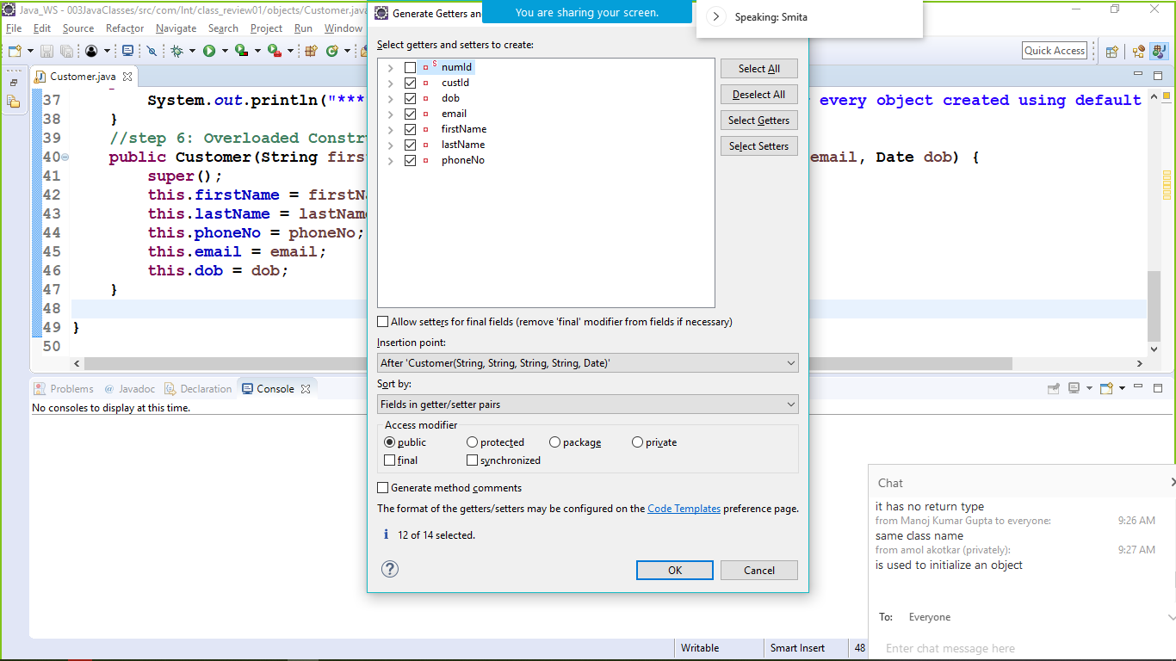

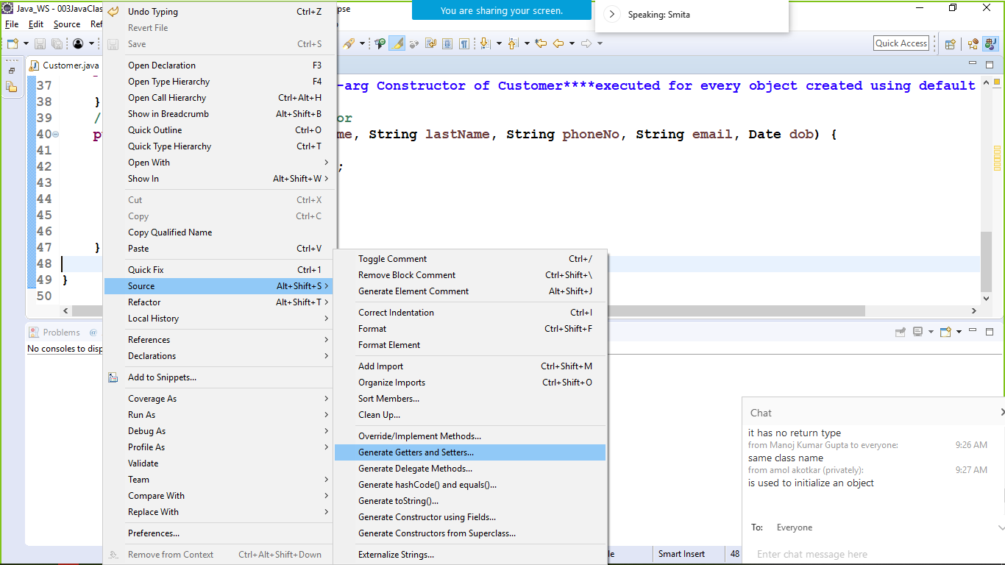

// step 8: Generate toString()

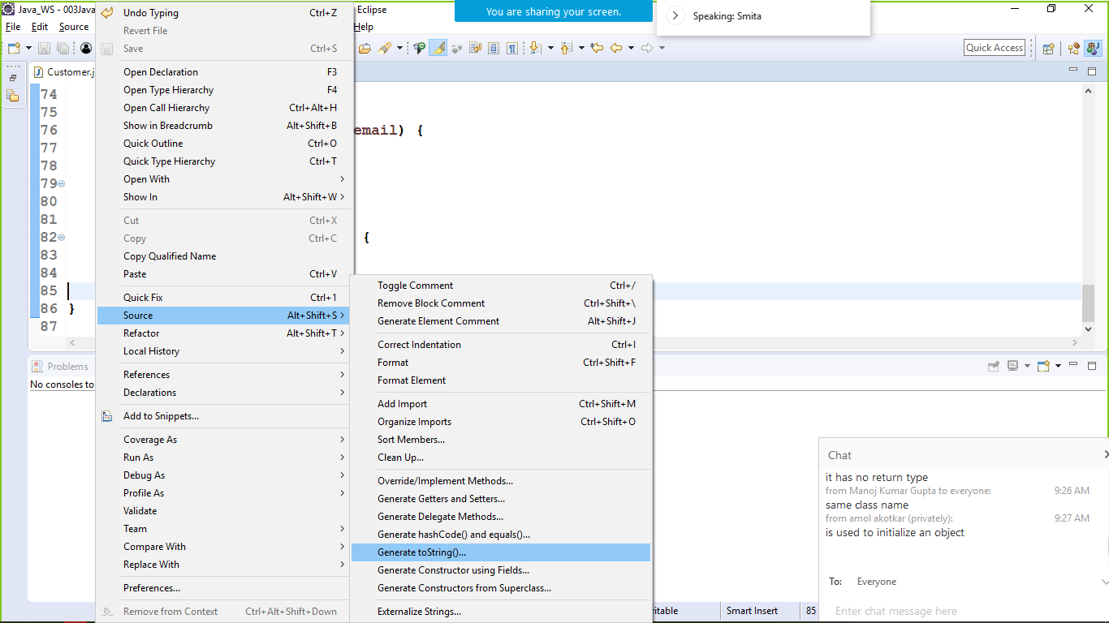

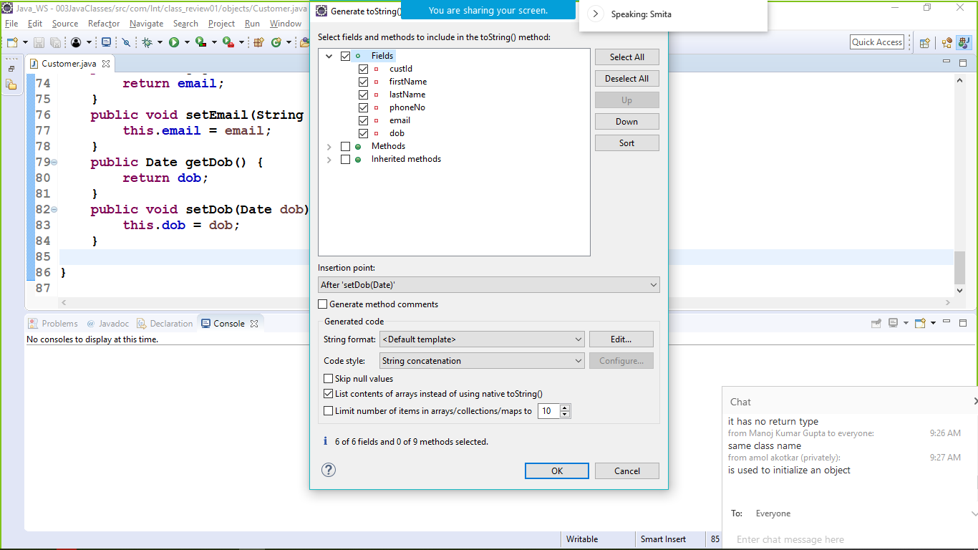

@Override

**public** String toString() {

**return** "Customer [custId=" + custId + ", firstName=" + firstName + ", lastName=" + lastName + ", phoneNo="

+ phoneNo + ", email=" + email + ", dob=" + dob + "]";

}

/***********/

//generating overloaded constructor in sub-class

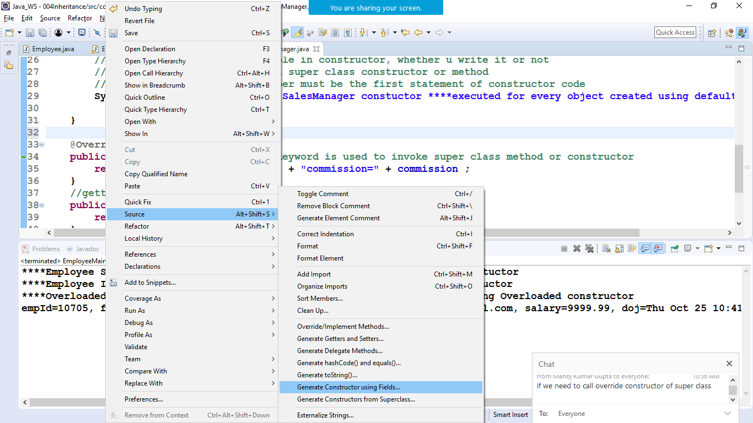

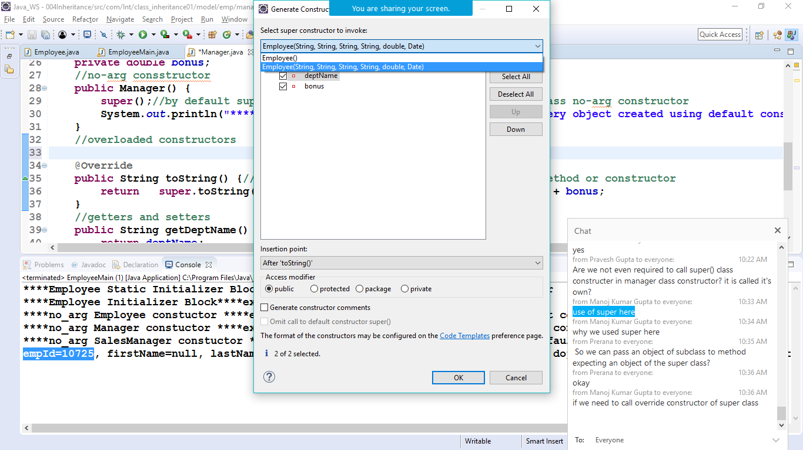

Override method in subclass

